Emilie Gallier
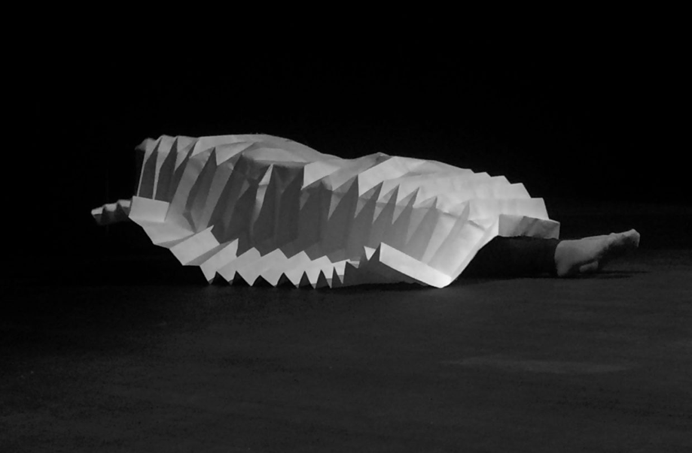
Papier Multiforme, Papier Comestible (Multiform Paper, Edible Paper)

T

THE DINER AS READER

Fransien van der Putt, December 19, 2018

Seen on December 13, 2018, Perdu, Amsterdam

Few choreographers in the Netherlands go their own way like Emilie Gallier does. She delved into dance notation and artistic research along with her dance training. Together these three focal points present an interesting oeuvre of sketches, settings, installations and performances -for the most part independently produced -which provide the concept of dance theatre with its own unique dynamic.

Whereas most choreographers place the body of the dancer at the core of their work, Gallier's work revolves around the body of the audience. And where many dance creators seek a sense of unity around those marvellously dynamic core bodies, Gallier is actually causing confusion.

At the start of the show each audience member must draw a card. There are various ways of attending the performance. At the magician's table, or on a chair with a tiny wee reading lamp with an equally small book made of edible paper held in your hands. It is dark for the rest, and everywhere audience members hang around in between the curtains which shroud the stage. Words and paper are played with. Levitation and other impossibilities abound.

In Papier Multiforme, Papier Comestible, the choreographer integrates a number of strategies from earlier projects into a mystifying, almost cannibalistic concept. Reading aloud side by side takes place again, and once more the notion of text slips into that of texture, turning all sorts of media, devices and materials into reading fodder, including one's own body and those of others.

In earlier projects, such as Sync (2011-2012) and Twist, In the Body of the Big Spectator (2012-2015), Gallier had already mirrored the positions of the dancer and the reader and had actually tried to allow these positions to alternate and converge. The audience is invited in all of her work to tune in to and out of different 'wavelengths' on the basis of the experience's layering and subsequently go their own way through a landscape of forms and expressions.

Hence a somewhat philosophically-imbued playing field emerges where questions are not only raised while nosing around here and there, yet an awareness of sensory and physicality comes to the fore as well. Seen in this way, the performance is more of a recital for the audience, who coordinate concentration and distraction, find a thematic approach to perspective and lines of sight, and juxtapose illusion and fascination with deception and the voracious mindset of an audience catapulted back into self-reliance.

Various forms of sensuality are not just being addressed, disciplinary differentials and genetical traits are used too. Paper Multiforme, Paper Comestible is a choreography and an installation, a failed magic trick and a picture book which you can enter into.

Magic or illusion play a crucial role in this. In collaboration with the magician Tilman Andris, Gallier developed paper forms that fold in to and out of each other and are able to keep on transforming. They are related to magic tricks, where distracting the audience is crucial in creating the illusion of impossible or magical motion. Instead of cards or rabbits, the Paper Multiforme, Paper Comestible are small, unsightly, forsaken bundles of paper which the performer Nina Boas attempts to send swiftly through time and space.

The book of edible paper, which is handed on to another part of the audience by the second performer Camille Gerbeau, has no back cover. With all the stumbling around in the dark between the seats with the minuscule reading lamps, minor mishaps are soon a matter of course. The leaves of the book flutter their way away from knees across the floor into the dark. It is up to the reader to continue reading at random, to create their own order or even reconstruct the original composition.

Although the poetry of objects and gestures, of voices, timbres and transformations generate an intimate and fascinating aesthetic, the choreographer also leaves the audience very much in the dark about the circumstances of the scene that has been set. A central focus point, thematic or formative, is absent. As in a dream, everything has to do with everything. Yet a central figure is lacking, unless the reader dares to present themselves as a theme and wants to see their own movements in interaction with or as part of Gallier's performance.

The central focus, as we know it from the old circus act where a lot of dance relies on placing that one physical movement at the centre, is replaced in Gallier's work by a scenic, theatrical architecture wherein movement ensues at various levels, and these movements can be seen from various perspectives as transformations. The audience therefore not only becomes a reader but also a wanderer.

The flux of attention and distraction, reading and interpretation is fuelled and disrupted by Gallier. Paper Multiforme, Paper Comestible requires a great deal of self-motivation on the part of the audience in order for the variations in affinity and engagement to constantly be made visible. Some spectators vanish into the performance like a fish into water or a child in a messy attic. Others become hesitant or get annoyed by the somewhat anarchistic combination of various signposted routes, and the not all too obvious invitation to start off as a reader.

The individual intimacy of reading which takes place in the armchair with a lampshade, on the bed or in the train
compartment is choreographically deconstructed by Gallier and is reprised in separate sections. The journey made from the armchair, and the absorption -or immersion (as it is called today) which accompanies it, become a choreographic playing field for all kinds of motion, transitions and transformations - some literally, others imaginary.

The beautiful drawings of Jamillah Sungkar in the book of edible paper depict in a wonderful way the departure of the writer and imagine the role of the reader as a diner. At that very moment a gigantic paper caterpillar slides past across the floor. You might think of the famous Verwandlung by Kafka. However, it is of course a generally accepted fact that not only the text and the intensity of reading alters the reader, but in turn, this steady-eating caterpillar on its way to pupation also appropriates the text.

The disappearance of the writer is not just necessary to make room for the reader. The reader also becomes co-author in the way they devour and digest the book, the text or any other fodder. In a certain sense, the whole of Gallier's work is an extremely poetic perspective on authorship, and a choreographic plea for co-creation.

Photo: Jamillah Sungkar
ELSE
S

(ELSEWHERE)

